**Application Deployment**

**Step 1:**

**Create an instance with following port:**

* Port 22 - ssh
* Port 443 - Https
* Port 80 – Http
* Port 8080 – Jenkins

**Install Git:**

* Update the package list - sudo yum update
* Install Git - sudo yum install git -y
* Verify the installation - git –version
* Clone a repository – git clone <https://github.com/sriram-R-krishnan/devops-build>

**Output:**

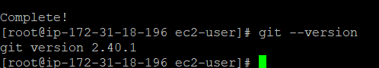



**Step 2 – Dockerize the application:**

* Create **Dockerfile**:

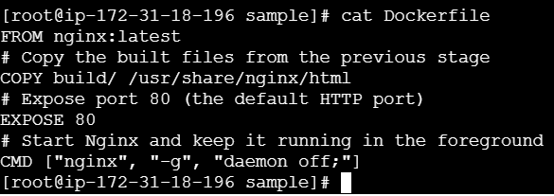

* Create **docker-compose file**:

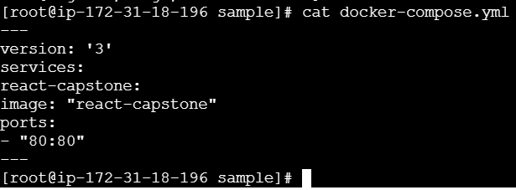

**Step 3 – Write bash scripts for creating and deploying docker images:**

* Building docker images – **build.sh**

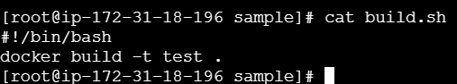

* Deploying the image to server – **deploy.sh**

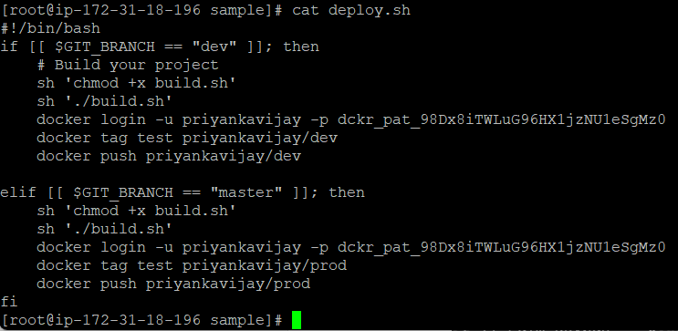

**Step 4 – Push the code to github (dev branch):**

* Create a repository in github – **final-pro**
* Link local repo to Github - **git remote add origin https://github.com/Priyankas1507/final-pro.git**
* For authentication we have to run the following command - **git remote set-url origin https://ghp\[email]/Priyankas1507/final-pro.git**
* Initialize the git – **git init**
* Create dev branch – **git branch dev**
* Switch to dev branch - **git checkout dev**
* Add file from working directory to staging area - **git add .**
* To commit the changes - **git commit -m “1st commit”**
* Push files from local repo to remote repo - **git push origin dev**

**Output:**

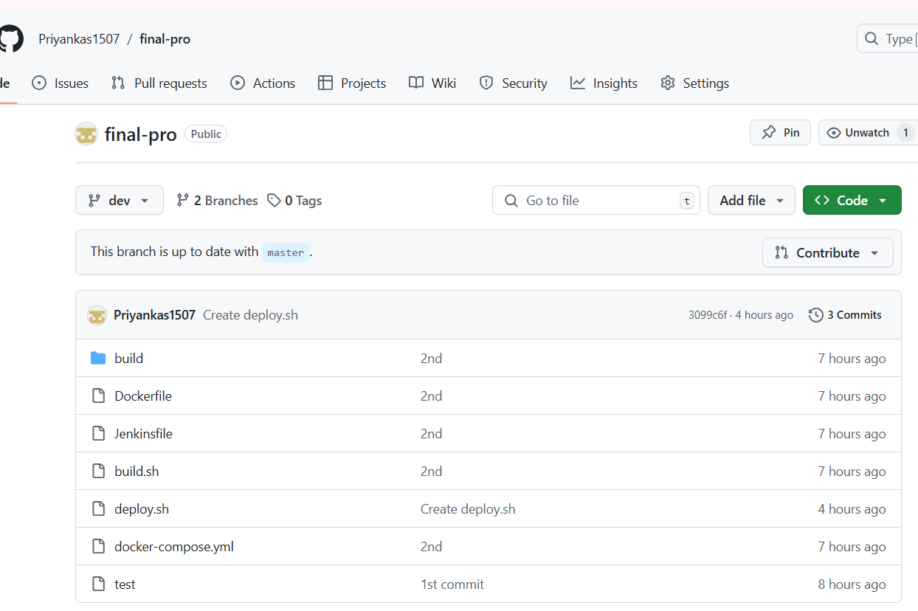

* Also push the code to master branch

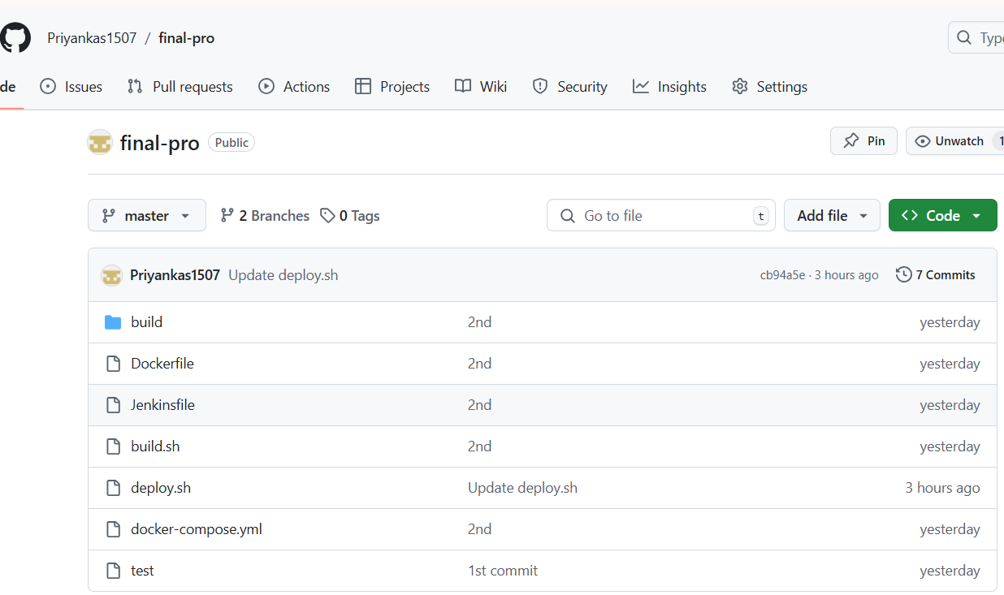

**Step 5 – Create repo in Docker hub:**

* Create prod and dev repo in docker hub
* Prod repo is private
* Dev repo is public

**Output:**

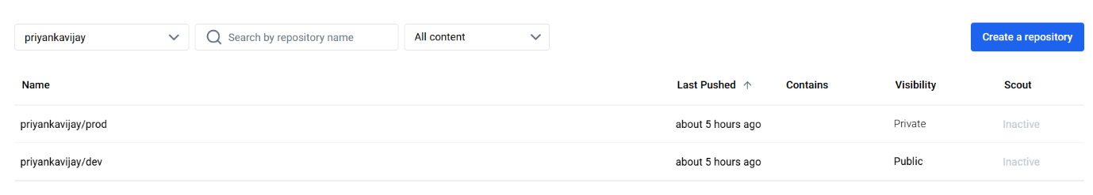

**Step 6 – Install Jenkins:**

* sudo yum update –y
* sudo wget -O /etc/yum.repos.d/jenkins.repo \https://pkg.jenkins.io/redhat-stable/jenkins.repo
* sudo rpm --import https://pkg.jenkins.io/redhat-stable/jenkins.io-2023.key
* sudo yum upgrade
* sudo dnf install java-17-amazon-corretto -y
* sudo yum install jenkins -y
* sudo systemctl enable jenkins
* sudo systemctl start Jenkins
* sudo systemctl status Jenkins

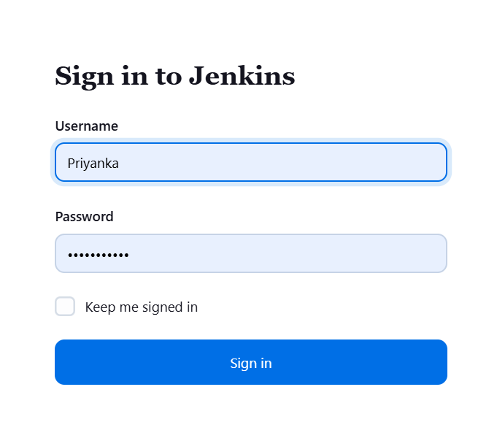**Step 7 – Create project in Jenkins:**

* Create multibranch pipeline project – **test2**
* Branch source – **git**
* Project repository – **https://github.com/Priyankas1507/final-pro.git**
* Add credentials – Enter Git username & token –> id -git
* Build configuration mode – **by jenkinsfile**
* Save & apply

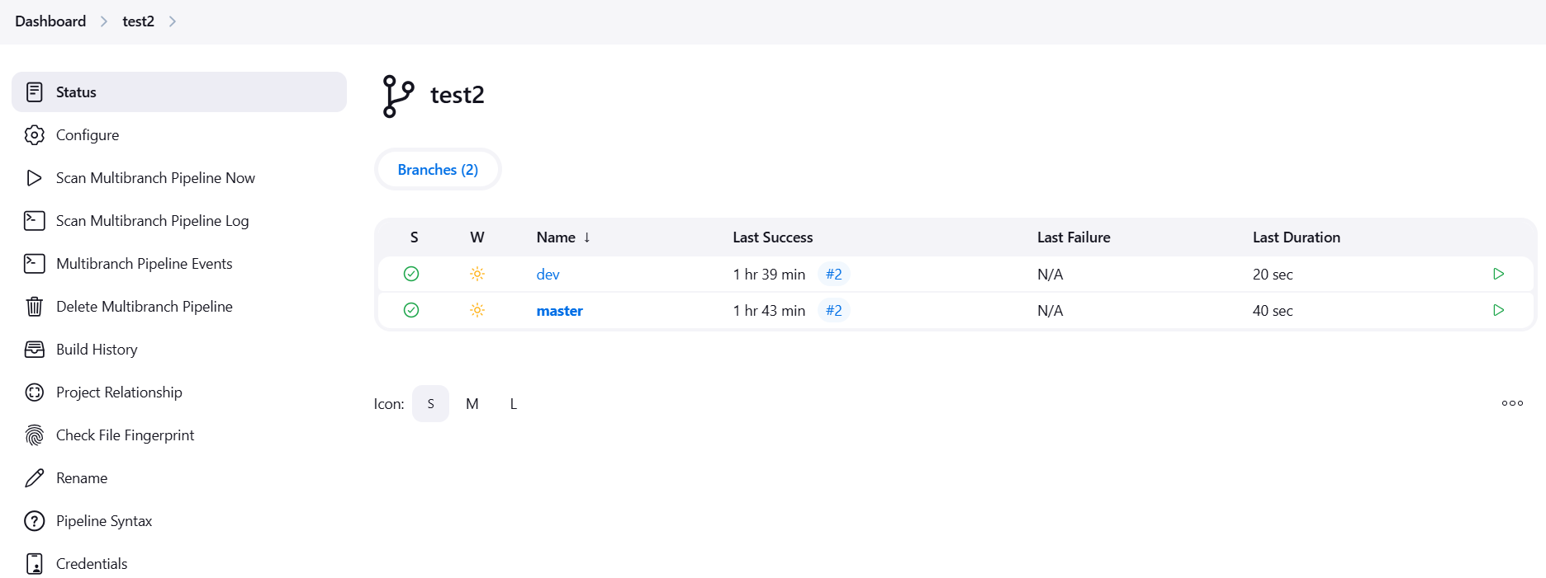

**Step 8 – Create webhook in github:**

* Github repository – **final-pro**
* Go to setting 🡪 **webhooks**
* Payload url - <http://35.88.163.78:8080/github-webhook/>
* Content type – **application//json**
* Enable ssl verification
* Click send me everything
* Create webhook

**Output:**

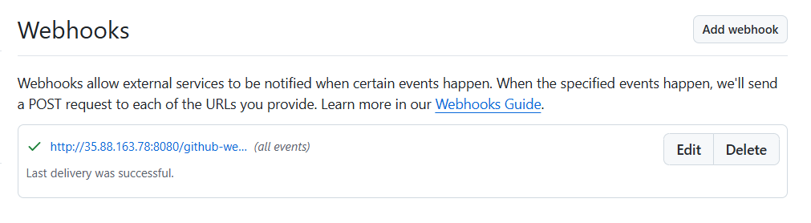

**Step 9 – Creating docker images:**

* When we commit the changes in dev branch webhook triggers then new image is created and pushed to Docker hub dev branch.

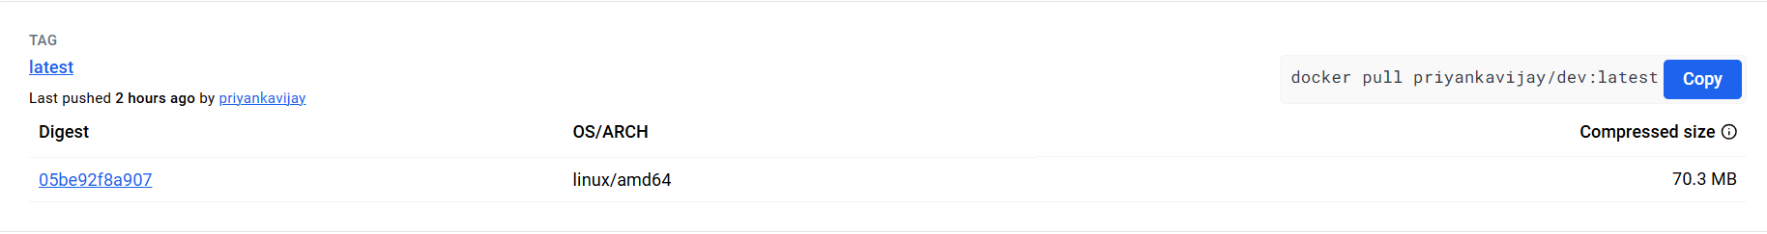

* When we commit the changes in master branch webhook triggers then new image is created and pushed to Docker hub master branch.

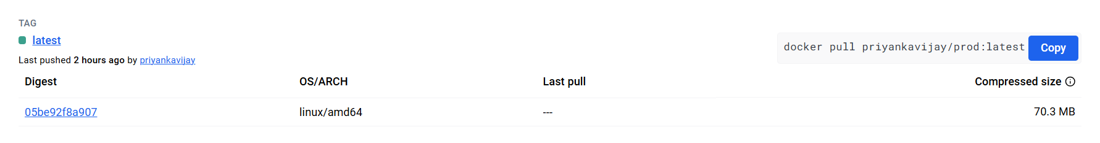

**Step 10 – Application Deployment:**

* Launch ubuntu machine with http port – 80
* Install docker – **sudo apt install docker.io**
* Pull the newly created docker image – **docker pull priyankavijay/dev:latest**
* Run the docker image – **docker run -itd -p 80:80 3f499b647648**
* Take the ip and hit it in the website

**Output:**

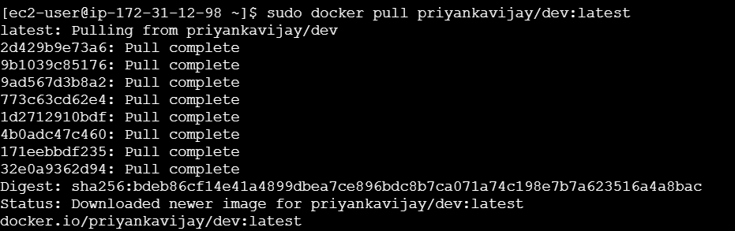

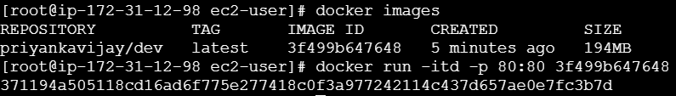

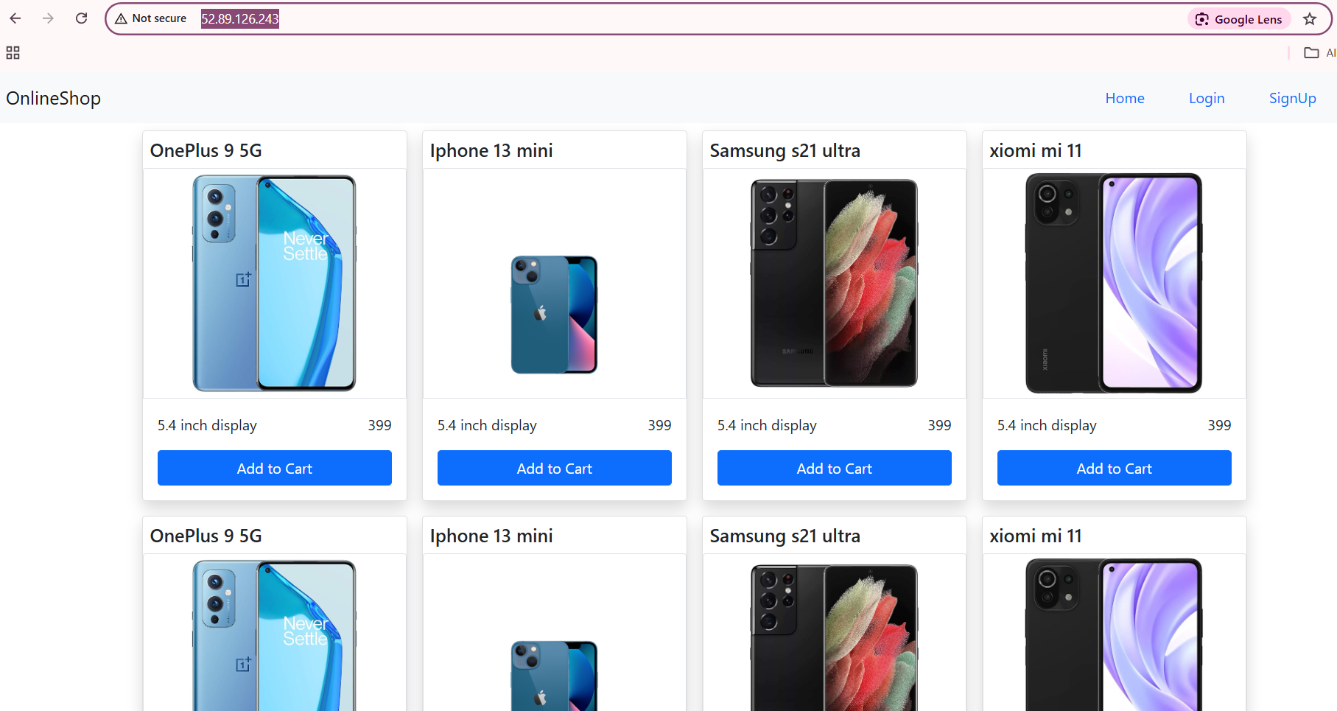

**Step 11 – Installation of Monitoring tool:**

In a ubuntu machine allow following port in security group.

* Prometheus – 9090
* Grafana – 3000
* Node exporter – 9100

**Prometheus Installation:**

* Create a script file and paste the following scripts – **vi prometheus.sh**

**Script file to install Prometheus**

#!/bin/bash

PROMETHEUS_VERSION="2.52.0"

wget https://github.com/prometheus/prometheus/releases/download/v${PROMETHEUS_VERSION}/prometheus-${PROMETHEUS_VERSION}.linux-amd64.tar.gz

tar -xzvf prometheus-${PROMETHEUS_VERSION}.linux-amd64.tar.gz

cd prometheus-${PROMETHEUS_VERSION}.linux-amd64/

# if you just want to start prometheus as root

#./prometheus --config.file=prometheus.yml

# create user

useradd --no-create-home --shell /bin/false prometheus

# create directories

mkdir -p /etc/prometheus

mkdir -p /var/lib/prometheus

# set ownership

chown prometheus:prometheus /etc/prometheus

chown prometheus:prometheus /var/lib/prometheus

# copy binaries

cp prometheus /usr/local/bin/

cp promtool /usr/local/bin/

chown prometheus:prometheus /usr/local/bin/prometheus

chown prometheus:prometheus /usr/local/bin/promtool

# copy config

cp -r consoles /etc/prometheus

cp -r console_libraries /etc/prometheus

cp prometheus.yml /etc/prometheus/prometheus.yml

chown -R prometheus:prometheus /etc/prometheus/consoles

chown -R prometheus:prometheus /etc/prometheus/console_libraries

# setup systemd

echo '[Unit]

Description=Prometheus

Wants=network-online.target

After=network-online.target

[Service]

User=prometheus

Group=prometheus

Type=simple

ExecStart=/usr/local/bin/prometheus \

--config.file /etc/prometheus/prometheus.yml \

--storage.tsdb.path /var/lib/prometheus/ \

--web.console.templates=/etc/prometheus/consoles \

--web.console.libraries=/etc/prometheus/console_libraries

[Install]

WantedBy=multi-user.target' > /etc/systemd/system/prometheus.service

systemctl daemon-reload

systemctl enable prometheus

systemctl start prometheus

* Change the ownership – **chmod +x prometheus.sh**
* Run the file – **sudo ./prometheus.sh**
* Hit the ip in browser – **http:// 35.163.20.24:9090**

**Output:**

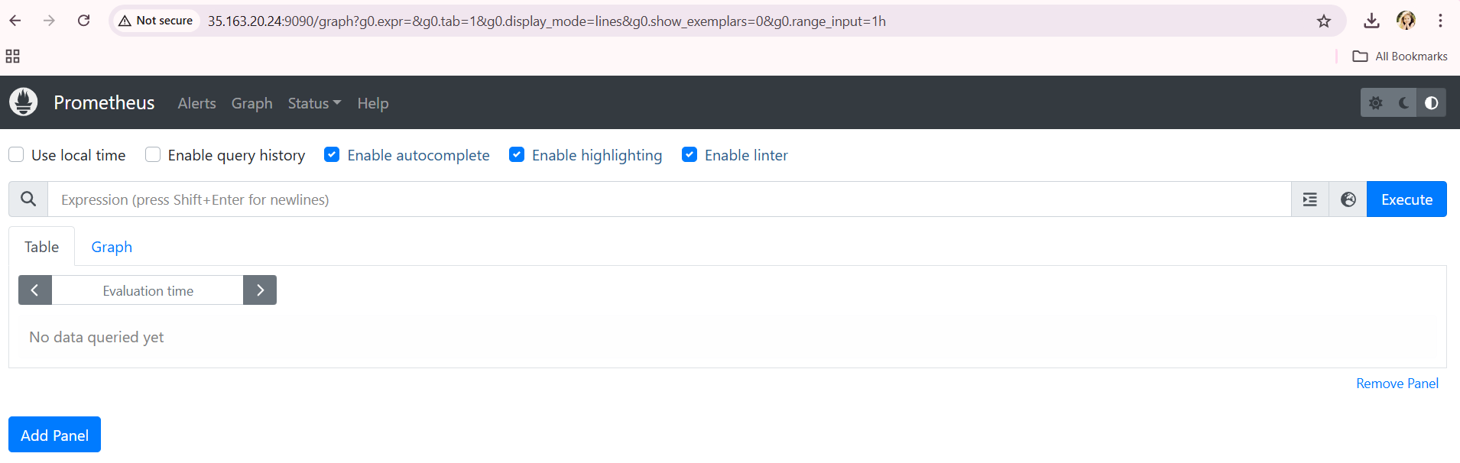

**Grafana Installation:**

* Create a script file and paste the following scripts – **vi grafana.sh**

**Script file to install Grafana**

#!/bin/bash

echo 'deb https://packages.grafana.com/oss/deb stable main' >> /etc/apt/sources.list

curl https://packages.grafana.com/gpg.key | sudo apt-key add -

sudo apt-get update

sudo apt-get -y install grafana

systemctl daemon-reload

systemctl start grafana-server

systemctl enable grafana-server.service

* Change the ownership – **chmod +x grafana.sh**
* Run the file – **sudo ./grafana.sh**
* Hit the ip in browser – **http:// 35.163.20.24:3000**

**Output:**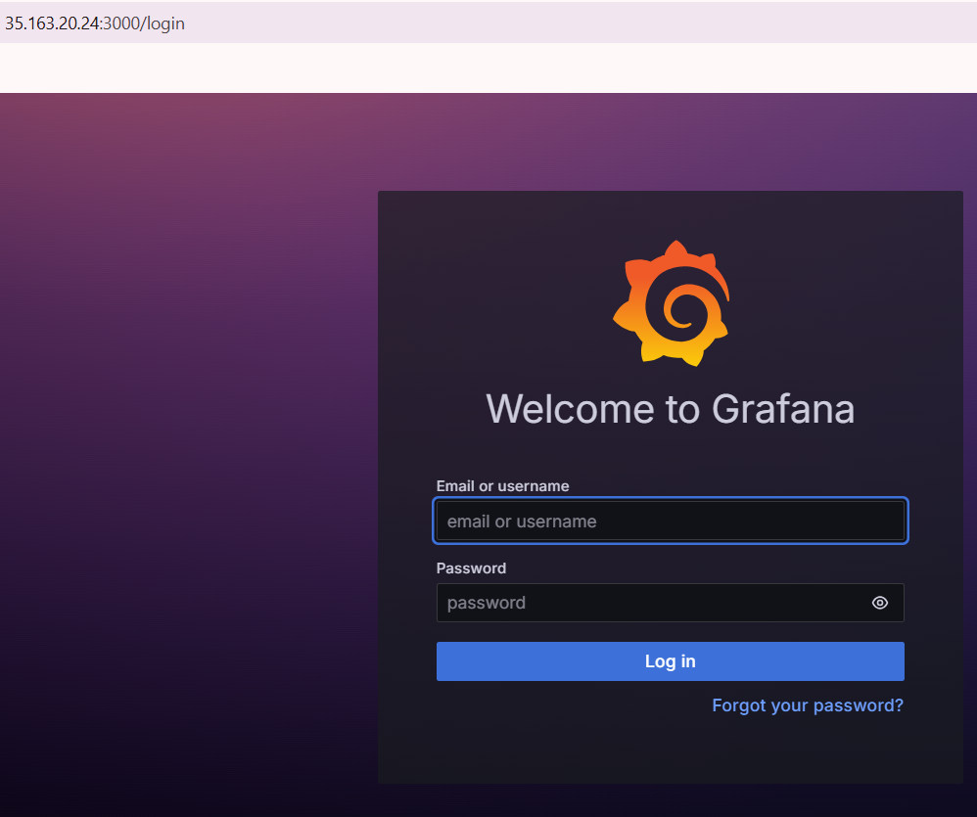

**Connect Prometheus to Grafana:**

* Login to Grafana
* In data source add prometheus server url - **http:// 35.163.20.24:9090**
* Save & test

**Create dashboard:**

* Go to dashboard 🡪 Select Import
* In Find and import dashboards for common applications at [grafana.com/dashboards](https://grafana.com/grafana/dashboards/) 🡪 give 3662 and load
* In Prometheus 🡪 Select default Prometheus and give import

**Output:**

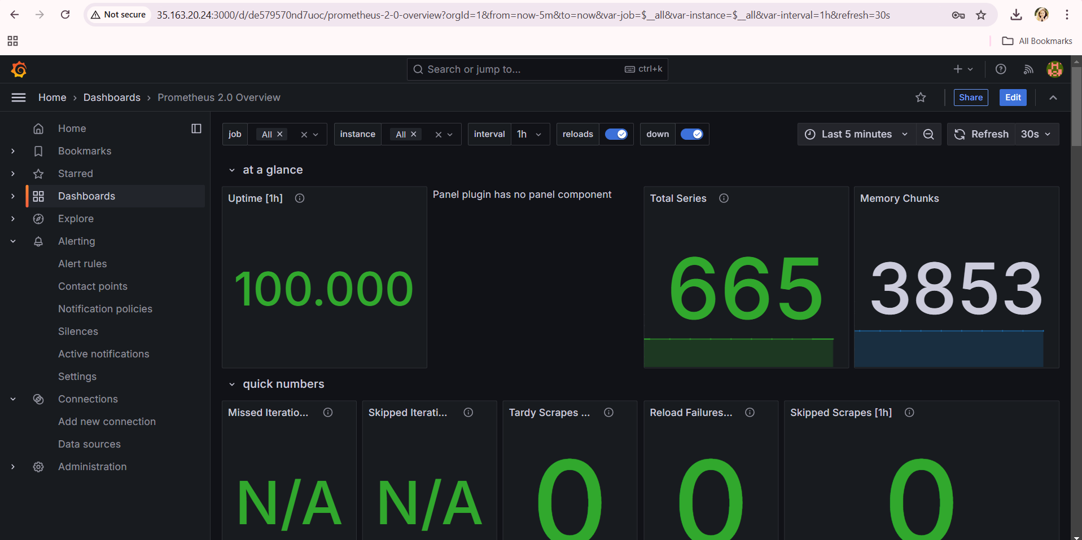

**Submissions:**

* Github repo url: <https://github.com/Priyankas1507/final-pro.git>
* Deployed site url: <http://52.89.126.243/>
* **Ec2 console:**

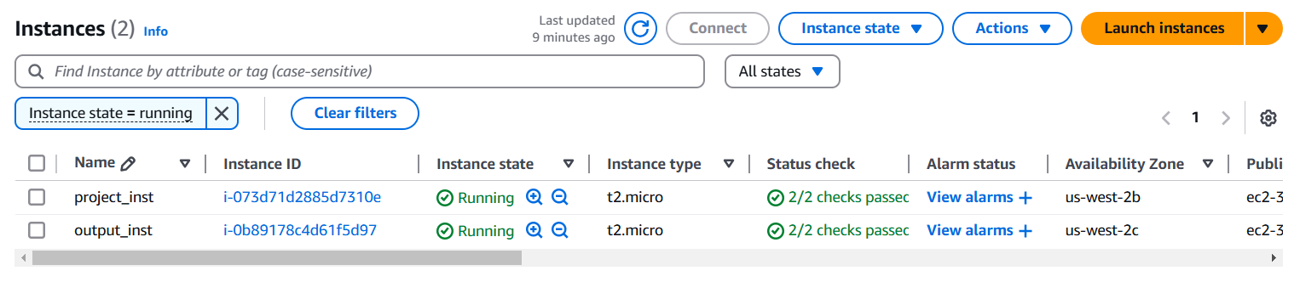

* **SG configs:**

